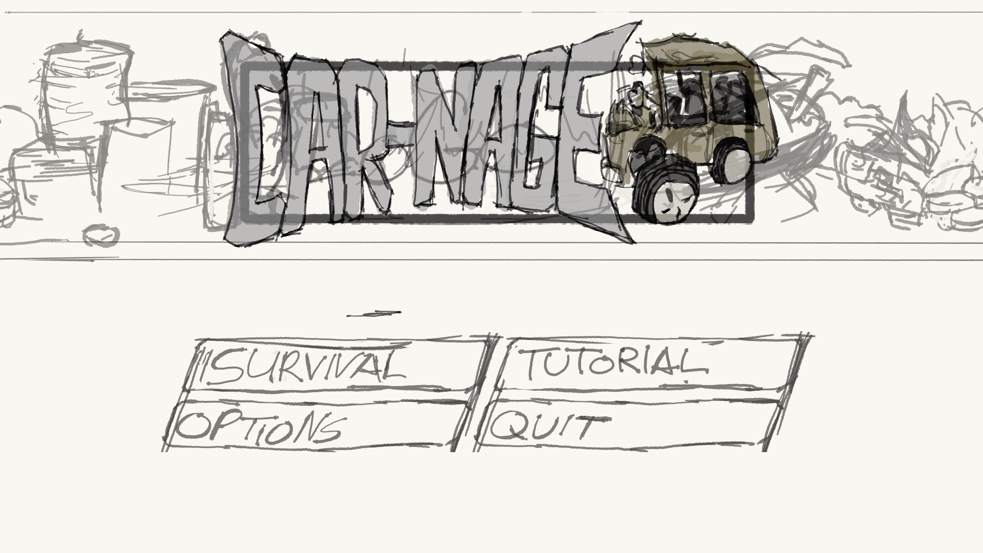

Game Design Document TrI-Guys

|  |  |  |  |
| --- | --- | --- | --- |
| Revision List | | | |
| Version | Author | Date | Comments |
| 0.1 | Andrew Scott | 24/09/2019 | Draft document |
| 0.2 | Tembani Mdaya and Thomas Riches | 24/09/2019 | Filled out multiple sections of the document. |
| 0.3 | Thomas Riches | 1/10/2019 | Changed a little bit about how the player controls their player character. |
| 0.45 | Tembani Mdaya | 1/10/2019 | Created enemies section under gameplay, Wrote something for Overview, Game Concept and Game Features. |

Table of Contents

Introduction 2

Refrences 2

platform and software 2

game Specification 3

Game Concept 3

story/setting 3

Game Features 3

objective 3

Graphics 3

Gameplay 3

overview 3

scaling difficulty 4

score system 4

Controls 4

combat 4

flowchart 4

Interface 4

Menu 4

Hud 4

camera 4

Team 4

Appendices 5

asset list 5

# Introduction

## Refrences

# platform and software

The game will be developed for use with either a keyboard or a controller on Windows, but could be made to work for mobiles and tablets. The game will be developed in the Unity game engine using a 2.5D environment.

# game Specification

## Game Concept

Describe what the game will be

The game will be a high-octane, fast-paced 2.5D Beat-Em-Up game set in a post-apocalyptic world where rules are no more. The player sets out on the Road as a search for fuel because he is constantly losing it on the go, but he is only later confronted with scavengers and baddies looking forward in taking the player down. Luckily, his car has a special absorb power to counter its terrible fuel usage and is able to gain fuel from defeating the enemy cars in front of them.

## story/setting

A bleak destroyed future where the sky accumulated the look of the sewers.

The aftermath of failed peace treaty signing leading to the horrid beginning of a new civilisation. World Order has been pushed off its’ balance, thus leaving the remaining humans to unleash their animal spirit.

## Game Features

What are the main features / mechanics we plan to put into the game

In most beat-em-up games, you never have the option to do quick dodges from enemy attacks in any direction so we are looking to implement a “Juke” sort of feature.

The game will also feature the traditional power-ups and pick-ups such as;  
Flimsy Fuel Cap – Stops Fuel/Health Drain for X seconds  
Piercing Plates – Increases Ramming damage  
General Guns – Piston, Shotgun, Machine Gun, Rocket Launcher etc  
Desert Diesel – Increases Speed for X seconds

## objective

In the current state of the game, the objective is to simply survive for as long as possible, accumulating high scores by defeating and outliving the enemy. The game will inevitably end when the difficulty becomes too great to overcome.

## Graphics

The graphics will be a mix of 2D and 3D, where the sprites are 2D but the background will have depth.

# Gameplay

## overview

The gameplay will be in the style of an arcade, side-scroller, beat-em-up game. The player will be against a small horde of enemies in front of them and the player has to clear the screen before they are able to proceed.

## scaling difficulty

Over time, the player will fight increasing odds. This comes in two forms: lifetime progression where the difficulty will slowly ram up the threat in a natural manner introducing more enemies and extra enemy types, and power progression where finding and equipping a weapon will provoke a specific enemy time – a Flyer for example – to come out to match how dangerous you are. Flyers themselves cannot be rammed into and must be shot down, giving their appearance more weight – you cannot attack them without a gun.

## score system

A scoring system will be put into play and displayed on the player’s screen. Their personal score will increase over their lifetime and will receive a boost when an enemy has been destroyed. A multiplier will kick it once at least three enemies have been dispatched.

## Controls

Car control is operated via the player’s peripheral.

## combat

Car combat will rely on a mix of aggressive ramming and high power weaponry. Ramming is an option that is always available to the player and depends running straight into an enemy to perform. Weapons however must be found and collected to use and have a limited amount of ammunition; once the player’s magazine is empty the gun will disappear. Shooting cannot be used without a gun

## Enemies

Normal Type: Just like the player’s car, nothing much special about it.  
Fast Type: This car is a lot faster than the players but it’s also a lot weaker.  
Brute Type: A big construction vehicles modified to deal as much damage as possible without leaving any trace, all at the price of speed.  
Hoverboard: A special vehicle made to fly over the enemy, dropping harmful things to the enemy.

## flowchart

# Interface

## Menu

The main menu of the game will show the player four options: Play, Tutorial, Options and Quit. The menu’s background will feature an infinite scroll with the game’s logo and menu buttons fixed in place.

## Hud

The heads-up display will contain a score counter, a fuel tank, whatever weapon the player is holding and a hazard light symbol – the hazard light will flicker and slowly become more and more red as time passes and the threat the player faces becomes too much to handle.

## camera

As the game is a side-scrolling survival the camera will be panned out to give the player the best possible view of the junkyard.

# Team

Andrew Scott – Programmer, Coordinator

Tembani Mdaya – Lead Artist, Composer

Thomas Riches – Programmer, Designer

# Appendices

## asset list